2026 Northern Redneck Riders Attendance Card &
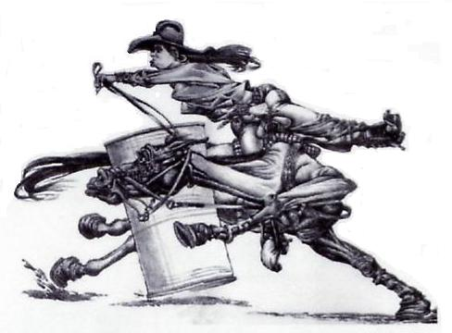
Finals Form
(One form per person and per Horse)
Rider’s Name: _______________________________________
Horse’s Name: ______________________________________
Division: __________________________________________
(Open, Intermediate, Junior or Pee Wee)

Requirements:
Open Rider 6 Jackpots and each Open Horse 3 Jackpots
Intermediate Rider 5 Jackpots and each Intermediate Horse 3 Jackpots
Junior Rider 4 Jackpots and each Junior Horse 2 Jackpots
Pee Wee Rider 4 Jackpots and each Pee Wee Horse 2 Jackpots

Jackpot Host Date Barrels Poles
(Please Check)

1. ____________________________________ __________________ ___________ ____________
2. ____________________________________ __________________ ___________ ____________
3. ____________________________________ __________________ ____________ ____________
4. ____________________________________ __________________ ____________ ____________
5. ____________________________________ __________________ ____________ ____________
6. ____________________________________ __________________ ____________ ____________

The Northern Redneck Riders Mission Statement
The purpose of the Northern Redneck Riders is to have fun with our family, friends and horses. To have and to teach strong sportsmanship, cheering everyone and encouraging new riders to come out and have fun no matter what level of rider and/or horse they are. Open and non-riders to be strong role models for our Junior and Pee Wee riders and to encourage proper dress attire. Promote safety of our sport and to teach our members to give back to our communities.
Remember... treat everyone as you would like to be treated!

Northern Redneck Riders Finals Entry Deadline: August 3 , 2026 @ 10 pm
Entry Fees
Open Barrels Entry $50 Open Poles Entry $50
Intermediate Barrels Entry $40 Intermediate Poles Entry $40
Junior Barrels Entry $30 Junior Poles Entry $30
Peewee Barrels Entry $20 Peewee Poles Entry $20
Buy in Fee: If you are short one barrel run and/or one pole run you can buy one of each. (Please DO NOT Buy in if you have the required amount of runs you needed to qualify) (Please read the Finals Rules)
Buy In Fee Barrels $100 Buy In Fee $100
Admin Fee per rider (not per horse, so if you ride multiple horses please only pay once) $10
Total Fees Enclosed $_______
Email & Etransfer to: northernredneckriders@hotmail.ca Password: Redneck 11

